**Release R130.0**

**Release and Installation Notes**

Note: Product Name (Title), Release (Subject) and Document ID (Keywords) are defined as (Microsoft Word) Fields specified in the parentheses earlier in this sentence. Use File-Properties to enter Values for each so that all occurrences will be updated automatically (including in Header/Footer).

Revision Date:

Notices and Trademarks

© Honeywell International SARL 2013. All Rights Reserved.

While this information is presented in good faith and believed to be accurate, Honeywell disclaims the implied warranties of merchantability and fitness for a particular purpose and makes no express warranties except as may be stated in its written agreement with and for its customer.

In no event is Honeywell liable to anyone for any indirect, special or consequential damages. The information and specifications in this document are subject to change without notice.

<Details of Registered Trademarks>

Provide details of registered trademarks. For example: “Honeywell, PlantScape, Experion, and TotalPlant are U.S. registered trademarks of Honeywell International Inc. ControlNet is a trademark of ControlNet International Ltd.”

MATLAB and Simulink are registered trademarks of The MathWorks, Inc.

Klocwork is a registered trademark of Klocwork, Inc.

Portions Copyright © GrapeCity, Inc. 1987-2012. All Rights Reserved.  
Other brand or product names are trademarks of their respective owners.

Honeywell International SARL

Z.A. La Pièce 16

1180 Rolle, Switzerland

<http://www.honeywell.com>

Contents

1 Introduction 4

1.1 About the OnRAMP Design Suite 4

1.2 About this Document 4

1.3 Technical Assistance 4

2 Contents of Release 4

3 New Features in R130.0 5

3.1 Windows 8 Support 5

3.2 Steady-State Simulation 5

3.3 MISRA-C Compliance 5

3.4 Model Export 5

3.5 Student Version 5

3.6 Continued Improvements 6

4 Getting Started 6

5 Upgrading to R130.0 6

5.1 Update the Software to R130.0 6

5.2 Update the OnRAMP Project Files to R130.0 6

6 Installation Procedure 7

7 Licensing 12

7.1 Requesting a License 12

7.2 Installing a License 13

8 Software Prerequisites and Compatibility 13

8.1 MATLAB and Simulink 13

8.2 C++ Compiler 15

8.3 .Net Framework 16

8.4 Windows Installer 16

8.5 Windows Operating System 16

8.6 Microsoft Excel 16

9 Uninstall Instructions 16

10 Third Party License Information 17

10.1 nLog 17

# Introduction

## About the Design Suite

The OnRAMP Design Suite is a development process and software tool for the generation of models and optimal control algorithms for a wide range of engine applications.

## About this Document

This document provides an overview of the OnRAMP Design Suite R130.0 software release, including contents, installation/uninstallation instructions, prerequisites, and technical support information.

This document uses the terms OnRAMP Design Suite and OnRAMP interchangeably.

## Technical Assistance

For technical assistance, contact OnRAMP Support by one of the following methods:

*Email:* [OnRAMP.Support@honeywell.com](mailto:OnRAMP.Support@honeywell.com)

*Phone:* +1-800-391-7795 (toll free in North America)

+1-778-300-1513 (worldwide)

Technical assistance contact information is also available from **About OnRAMP Design Suite** under the **Help** menu within the application.

The OnRAMP Design Suite includes a help file that can be accessed through the **Start** menu under   
**All** **Programs 🡪 OnRAMP** or from the **Help** menu within the application.

Provide concise contact information for customer support, training & product information.

Example:

Global Technical Assistance Centers (contact information by country/region),

Honeywell Support On-line (http://www.honeywell.com/ps) and

Training Classes (<http://www.automationcollege.com>).

Include roles & organizations, not rather than names of individuals. Consider referencing existing information sources where appropriate.

# Contents of Release

The OnRAMP Design Suite R130.0 release includes the following item:

|  |  |
| --- | --- |
| **Part Description** | **Part Number** |
| **Installation Package** | N/A  The installation package is distributed electronically. The package includes these Release and Installation Notes  (PN 6510020377). |

# New Features in R130.0

New features for the R130.0 release are highlighted in this section.

## Windows 8 Support

The R130.0 release introduces support for the Microsoft Windows 8 Operating System. The release also introduces support for MathWorks R2012A, the first MathWorks release validated on Windows 8.

## Steady-State Simulation

The R130.0 release added new functionality in the workflow to perform steady-state simulations. This time saving feature allows users to analyze model nonlinearities to determine the impact of the control variables on the operation of their engine. Steady-State Simulation aids the control design process by helping the user understand the nonlinear aspects of the engine, identify problematic areas, and optimize the control solution.

## MISRA-C Compliance

The runtime code that is deployed by the OnRAMP Design Suite is now MISRA-C:2004 compliant. Complying with this standard helps to ensure that the runtime code is robust, portable, and consistent with industry expectations. MISRA-C compliance was verified with Klocwork®’s Insight tool.

## Model Export

The R130.0 release allows users to deploy their identified model for enterprise-wide use, without requiring an OnRAMP license. The identified model can be used in Simulink, and provides users with the flexibility to perform tasks outside of the OnRAMP Design Suite.

* Exporting the identified engine model enables many uses, such as examining the performance of engine systems away from the test stand, deploying the model in a HIL system, or analyzing/comparing the performance of different controllers.
* Exporting both model and controller allows users to perform more in depth analysis of the controller in a MATLAB/Simulink environment. As an example, users could analyze closed-loop robustness to perturbations in model components such as injection quantity and cooler effectiveness.

Additional MathWorks® licensed product prerequisites, and supported compilers, are needed to use the Model Export feature. Those prerequisites are listed in Section 8.

## Student Version

The R130 release introduces a Student Version of the Design Suite. The student version *does* *not* allow users to deploy the runtime source code, as the version is intended for use in purely simulated environments[1]. The OnRAMP software installation package is the same for all versions of the product, as the license installed on the computer is used to determine which version the user is entitled to use.

## Continued Improvements

The R130.0 release incorporates over 150 fixes and enhancements, many of which came from customer feedback.

See the Bill of Material pertaining to this release for specific items to include in this section.   
For Express Delivery this section may be updated to include a list of files included in the release and the following tables may be removed if no model numbers apply.

# Getting Started

To get started with installing the OnRAMP Design Suite, you need the installation package (see Section 2). The instructions for installing the OnRAMP Design Suite are provided in Section 6 of this document.

The OnRAMP licensing process requires that you send a *hostid* file to Honeywell through the license configuration utility. You then receive a *ULMLicense* file back from Honeywell.

Installing the ULMLicense file allows you to start using the OnRAMP Design Suite. You can successfully install the OnRAMP Design Suite without completing the licensing process. However, you need to complete the licensing process to start using OnRAMP. For details on the licensing process, see Section 7.

The OnRAMP Design Suite requires certain third-party software applications, or prerequisites, to be installed on the computer along with the Design Suite. While four of these third-party applications are included with the OnRAMP installation and require no additional downloads by the user, two other third-party applications need to be independently installed and licensed. You can successfully install the OnRAMP Design Suite without having these two independent prerequisites already installed on your computer. However, you need to have these prerequisites installed to start using the OnRAMP Design Suite. For further details, including supported versions of the prerequisite software, see Section 8.

OnRAMP Design Suite R130.0 cannot be licensed in a virtual machine.

# Upgrading to R130.0

Upgrading to R130.0 may require two steps: updating the software to R130.0, and updating your project file to take advantage of the improvements in R130.0.

## Update the Software to R130.0

The R130.0 installation will update previous versions of OnRAMP that have been installed on your computer. The installation steps for updating OnRAMP are the same as for an installation on a clean machine, and can be found in Section 6. OnRAMP and MATLAB should not be running during the installation/upgrade process.

## Update the OnRAMP Project Files to R130.0

When opening a project file that was saved in a release prior to R130.0, you may see a message describing the steps necessary to complete the upgrade process.

If you see upgrade-related messages, follow the instructions to update the OnRAMP project file.  
Once all steps are completed and the project is saved, the message will no longer appear.

When OnRAMP saves a project file from a previous release in the R130.x format, it saves a backup copy of the original with the original version name inserted into the backup file name.

Instructions on how to replace older engine blocks with the R130.x version are available in the help file, in a dedicated section called **Replacing the Engine Block** under **Model Configuration**.

# Installation Procedure

To install the OnRAMP Design Suite software application:

1. Download the installation package and double-click on the setup.exe file.

|  |  |
| --- | --- |
|  | **ATTENTION:**   1. The installer requires administrator privileges on Windows 7. If User Account Control (UAC) is enabled, you are prompted to elevate the privileges of the setup application to proceed with the installation. If you are prompted to elevate privileges, select **Yes**. You may also need to provide credentials of a user with administrator privileges, if the current account does not have these privileges already. 2. The installer will update files for use within MATLAB. Ensure that MATLAB is not running when installing the OnRAMP Design Suite. |

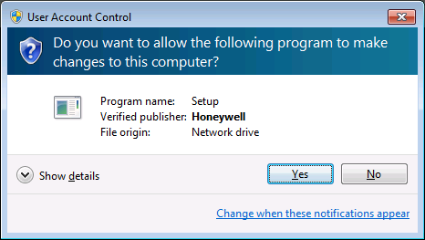

1. If you get a dialog notifying you that prerequisites are required, install the prerequisites as suggested (see Section 8 for prerequisite details).   
     
   If you are installing on Windows 8 and require the .Net 3.5 Framework to be installed, Windows will require that you download the Framework from the Microsoft website. If you are not connected to the Internet, you can install the Framework from a Windows 8 installation media. Details on installing the .Net 3.5 Framework on the Windows 8 operating system are available at:  
   <http://msdn.microsoft.com/en-us/library/hh506443.aspx>   
     
   If you require the .Net 4.0 Framework prerequisite, you will be asked to agree to the Microsoft End User License Agreement to install the software package.

The process of installing the prerequisites may require a reboot.

1. Once the prerequisites are installed, you are presented with an OnRAMP installation welcome dialog. If the OnRAMP installation welcome dialog does not appear after the prerequisites installation, double-click on the *setup.exe* file to restart the OnRAMP installation process. Select **Next**.

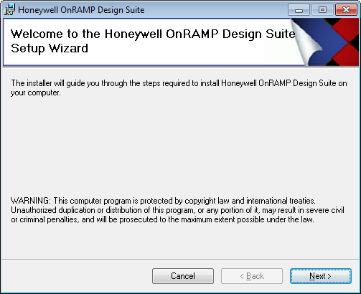

The License Agreement dialog appears.

1. If you agree to the license terms, click the *I Agree* radio button and select **Next**.

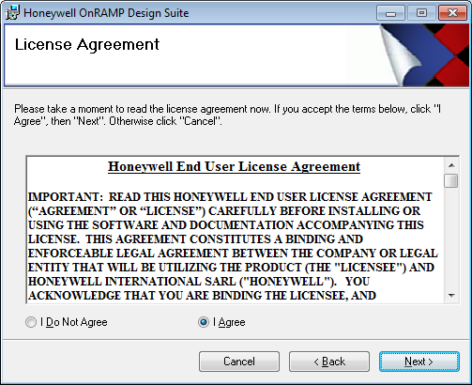

After agreeing to the license terms, you are prompted for the installation folder.

1. Select **Next** to proceed with the default installation folder.

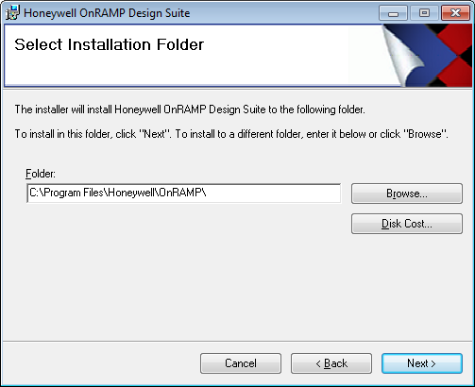

The installation confirmation dialog appears.

1. Select **Next** to start the installation.

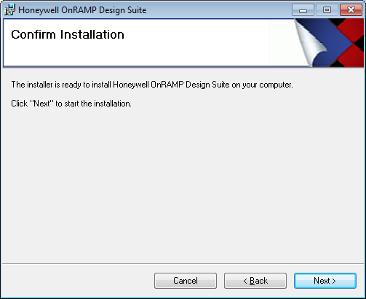

1. If you are missing any of the independent prerequisites, you will be notified during the installation process. The prerequisite messages are informational and do not impact the installation process. However, you will need to install the prerequisites before using OnRAMP.

See Section 8 for the list of software prerequisites and their validated versions.

If you do receive a prerequisite message(s), acknowledge the message(s) by selecting **OK**.

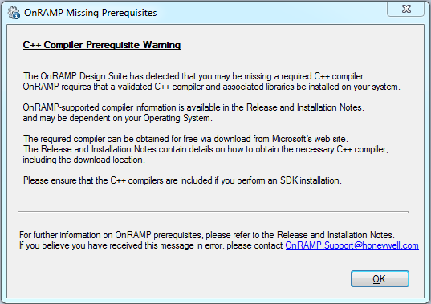

1. Towards the end of the installation, you may be prompted to license the software through the OnRAMP License Management Utility. Cancelling the license configuration by closing the window will not impact the installation process.

Instructions on completing the licensing process after the installation are available in Section 7.

1. Complete all fields on the **OnRAMP License Request** dialog and select **Next**.

For the **Name** field, the user’s full name should be entered. All fields need to be filled in for the **Next** button to become available for selection.

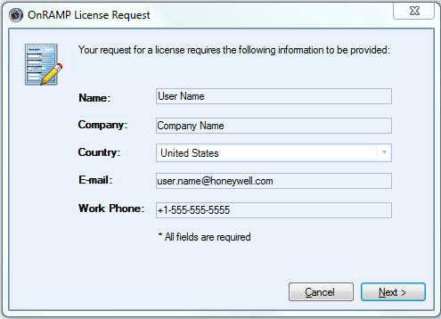

The license submission dialog appears.

1. Check the information and select **Submit** to send the license request to the OnRAMP support team or select **Back** to correct the input.

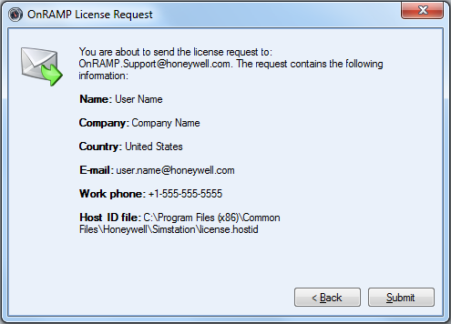

1. The license configurator emails your *hostid* file to the OnRAMP Support team.

If this step succeeds, the dialog will display a message indicating that the request was sent successfully. If your email client performs a send on a periodic basis, you can initiate a send to prevent any delays in receiving a license.

Close the dialog and go to Step .

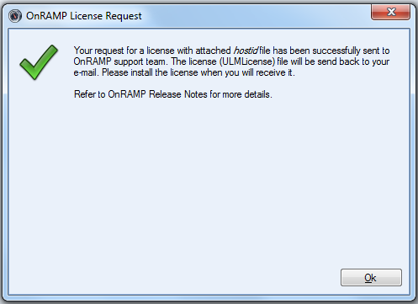

If the automated email process fails, you may get an error message indicating that you do not have an email client.

1. If you receive a message indicating that the license tool has failed to send the email, review the additional instructions to manually send the license file to the OnRAMP Support team.

Send an email to [OnRAMP.Support@honeywell.com](mailto:OnRAMP.Support@honeywell.com), with the hostid file included as an attachment. The hostid file can be found in the following location:

*C:\Program Files (x86)\Common Files\Honeywell\SimStation\license.hostid*

If you are running a 32-bit Operating System, remove (x86) from the path shown above.

Close the License Management window by using the red X in the top right corner of the dialog or by selecting **Close**.

1. Select **Close** on the final dialog to complete the installation.

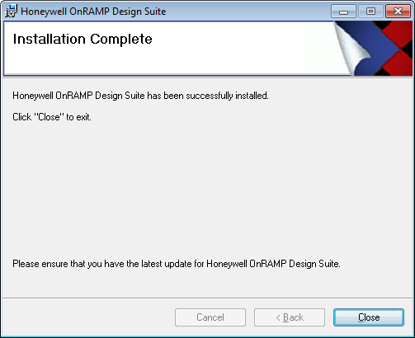

There is now a shortcut on the desktop as well as in your **Programs** menu. These shortcuts can be used to launch the OnRAMP Design Suite application.

Once you have completed the *hostid* submission, you need to install a license before using the OnRAMP application. Instructions on installing the license are available in Section 7. Highlight important things to know before proceeding (Example: “It is strongly recommended that all customers contact the Honeywell Technical Assistance Center prior to conducting an on-process migration.”For Maintenance Releases:

# Licensing

The OnRAMP Design Suite requires that the end user be licensed to use the software’s functionality.

The OnRAMP licensing approach is a Honeywell proprietary licensing method called ULM. The licenses are associated with the named user and the hardware profile where OnRAMP is installed, and cannot be transferred between computers.

## Requesting a License

During the OnRAMP installation, you are prompted with a license dialog.

If you close the licensing dialog during the install, or it fails because you do not have an email client on the computer, you can re-launch the Licensing Wizard from the machine where OnRAMP was installed by going to the **Start** menu and selecting **All** **Programs🡪OnRAMP🡪Generate OnRAMP License Request** or from the OnRAMP **Help** menu (**OnRAMP 🡪Help🡪License Request)**.

After launching the Licensing Wizard, follow the licensing steps (steps 9-12) provided in Section 6.

If the email transmission fails due to a missing email client, follow the manual steps provided in step 12 of Section 6 to submit your *hostid* file to OnRAMP Support.

## Installing a License

After receiving your license request, the OnRAMP support team reviews the information and emails a license (*ULMLicense)* file back to you. This *ULMLicense* file needs to be installed to license the computer that will be running the OnRAMP software.

To install the *ULMLicense* file:

1. Copy the *ULMLicense* file to the computer that will be running OnRAMP.

The folder location where the file is copied to does not impact the remaining steps.

If your email client is on the machine that is running OnRAMP, this step can be ignored.

1. Double-click the *ULMLicense* file.

The *ULMLicense* file extension is registered to the appropriate license installer.

Double-clicking the file runs a tool to import the license information for use with the OnRAMP application. On a successful import, you see this message:

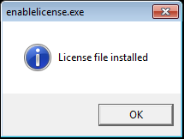

It is not possible to install a ULM license on a virtual machine.

If you have any licensing problems, contact the OnRAMP Support team (see Section 1.3).

# Software Prerequisites and Compatibility

The OnRAMP Design Suite requires the installation of certain third-party software applications.

They are referred to here as prerequisites, and include:

* MATLAB and Simulink   
  (the Control System and Optimization toolboxes are required,   
   the Model Export feature requires additional products as described in Section 8.1)
* C++ Compiler
* .Net Frameworks 3.5 SP1 & 4.0
* Windows Installers 3.1 & 4.5

Two of the prerequisites – MATLAB/Simulink and the Visual C++ compiler – must be downloaded and installed separately from the OnRAMP software.

The other prerequisites – the .Net Frameworks and Windows Installers – require no additional downloads and are installed as a part of the OnRAMP installation process if required.

## MATLAB and Simulink

The OnRAMP Design Suite requires that MATLAB and Simulink be installed on the same computer.

MATLAB and Simulink require their own licenses; install them separately.

MATLAB and Simulink are developed by the MathWorks and are packaged with MathWorks software releases. The following MathWorks releases were validated for use with the OnRAMP R130.0 release.

As both Simulink and MATLAB are required, their respective versions are also included below (in parentheses).

|  |  |
| --- | --- |
| **MathWorks Release** | **Architecture(s)** |
| Release 2009B SP1  (MATLAB 7.9.1 and Simulink 7.4.1) | Same as Operating System  (32-bit) |
| Release 2010A  (MATLAB 7.10 and Simulink 7.5) | Same as Operating System  (32-bit or 64-bit) |
| Release 2010B SP1  (MATLAB 7.11.1 and Simulink 7.6.1) | Same as Operating System  (32-bit or 64-bit) |
| Release 2011A  (MATLAB 7.12 and Simulink 7.7) | Same as Operating System  (32-bit or 64-bit) |
| Release 2011B  (MATLAB 7.13 and Simulink 7.8) | Same as Operating System  (32-bit or 64-bit) |
| Release 2012A  (MATLAB 7.14 and Simulink 7.9) | Same as Operating System  (32-bit or 64-bit) |

The following MATLAB toolboxes are required to use the OnRAMP R130.0 Design Suite.

|  |
| --- |
| **MATLAB Toolbox** |
| Control System Toolbox |
| Optimization Toolbox |

Additional MATLAB products are required to use the Model Export feature, which was introduced in the OnRAMP R130.0 Design Suite release. Those additional MathWorks products are described here.

Starting with the MathWorks R2011A release, the MathWorks restructured the Real-Time Workshop product, with the functionality being divided into the Simulink Coder and the MATLAB Coder products. The differences between the versions are reflected in the two prerequisite tables below.

|  |
| --- |
| **MathWorks Product (for R2011A and later) – required for Model Export functionality** |
| Simulink Coder |
| MATLAB Coder |

|  |
| --- |
| **MathWorks Product (prior to R2011A) – required for Model Export functionality** |
| Real-Time Workshop |

These MathWorks products also require that a supported compiler be installed on the computer.  
The MathWorks website has details regarding their supported compilers for particular versions and architectures. This information is available at the following URL:

<http://www.mathworks.com/support/sysreq/previous_releases.html>

See the right-most column in that table for supported compiler information.

For example, with MathWorks R2011A installed on a 64-bit Windows OS, the supported compilers are:

<http://www.mathworks.com/support/compilers/R2011a/win64.html>

In this scenario, the user will require Microsoft Visual C++ 2010 Express & Windows SDK 7.1 (both products are free of charge) to use the MATLAB Coder and the Simulink Coder with R2011A.

The Model Export feature in the OnRAMP Design Suite has been validated against the Visual Studio 2008 and Visual Studio 2010 compilers, which are included in the MathWorks-supported configurations for the MATLAB Coder/Simulink Coder/Real-Time Workshop products.

The MATLAB installation must also be registered as a COM server on your computer to be available for use. If a supported version of MATLAB is installed but not available for selection in the OnRAMP Preferences dialog, the MATLAB installation will need to be registered as a COM server.

To force MATLAB registration as a COM server, see the *–regserver* command details at

<http://www.mathworks.com/help/techdoc/ref/matlabwindows.html>

## C++ Compiler

The OnRAMP Design Suite requires that a C++ compiler be installed on the computer running OnRAMP.

The validated compiler for use with OnRAMP when running Windows 7 or Windows XP is the Microsoft Visual C++ Compiler that is provided with Visual Studio 2008. If you do not have Visual Studio 2008 available, the compiler is available for free with the appropriate Windows Software Development Kit (SDK), available at the link provided below.

<http://www.microsoft.com/download/en/details.aspx?displaylang=en&id=3138>

Please ensure that the C++ compilers are included as a part of your SDK installation.

If you have Visual Studio 2008 SP1 Express installed on a 64-bit OS, please note that you must also install the SDK to get the 64-bit compilers needed by OnRAMP.

For MathWorks R2012A, you will need to install a newer version of the Windows SDK (version 7.1) than what is described above. This updated SDK is required by the MATLAB and Simulink Coder for Model Export functionality. This SDK version is validated for OnRAMP use with Windows 8 and MathWorks R2012A, and is available at:

<http://www.microsoft.com/en-us/download/details.aspx?id=8279>

|  |  |  |
| --- | --- | --- |
| **C++ Compiler Release** | **Operating System** | **Architecture(s)** |
| Microsoft Visual C++ 9.0 | Windows XP/ Windows 7 | Same as Operating System (32-bit and 64-bit) |
| Microsoft Visual C++ 10.0 | Windows 8 | Same as Operating System (64-bit) |

## .Net Framework

The OnRAMP Design Suite requires the installation of .Net Framework versions 3.5 SP1 and 4.0. The OnRAMP installation package installs these versions of the .Net Framework on your computer if they are not already installed.

## Windows Installer

The OnRAMP Design Suite requires the installation of Windows Installer versions 3.1 and 4.5.

The OnRAMP installation package installs these versions of the Windows Installer on your computer if they have not already been installed.

## Windows Operating System

The OnRAMP Design Suite has been validated against the following Operating Systems:

|  |  |
| --- | --- |
| **Operating System** | **Architecture(s)** |
| Microsoft Windows XP Professional SP3 | 32-bit |
| Microsoft Windows 7 SP1 | 32-bit and 64-bit |
| Microsoft Windows 8 | 64-bit |

## Microsoft Excel

The OnRAMP Design Suite does not require Microsoft Excel as a prerequisite, and is able to import data from, and export data to, the Excel spreadsheet format without Microsoft Excel being installed. The Design Suite works with spreadsheets of version Excel 97 or later.

To open, view, or print an Excel spreadsheet, the computer must have Microsoft Excel, or the free Microsoft Excel Viewer, installed. The Microsoft Excel Viewer is available at:

<http://www.microsoft.com/download/en/details.aspx?id=10>

Use this section to highlight “late-breaking news” & particular changes. Example: qualifications with other Honeywell products.

If this section is more than 1 page long,rather than specifying compatibility info in-full within this section, consider referring to existing documents or providing details in the Appendix.

Specify what has changed relative to prior release. Make reference to relevant documents (e.g. section in Software Change Notice for prior release).

If standard documentation is delivered with the release:

Reference or include additions/modifications/deletions to User Assistance materials that could not be included in the standard documentation.

Reference or include additions/modifications/deletions relative to User Assistance materials from prior release.

If no standard documentation is delivered with the release:

If information is not sufficient in the section describing the changes, include additions/modifications/deletions relative to User Assistance materials from prior release.

# Uninstall Instructions

To uninstall the software, go to the **Control Panel**, select **Uninstall a Program** (or **Add\Remove Programs**)and select **Honeywell OnRAMPDesign Suite**to uninstall.

Uninstalling OnRAMP does not uninstall any of its prerequisites.

To uninstall the prerequisites, do it independently through the **Control Panel**.

|  |  |
| --- | --- |
| Att | **ATTENTION:**  Ensure that OnRAMP and MATLAB are not running when uninstalling OnRAMP. Leaving these applications running while trying to uninstall OnRAMP can interfere with the uninstall process. |

# Third Party License Information

Honeywell products use software provided by third parties, including open source software, which may include those components listed below. The following copyright statements and licenses apply to various components that are distributed with various Honeywell products, and this Honeywell product does not necessarily use all of the third party software components referred to below. The license terms apply only to the respective component and do not apply to the Honeywell software.

## nLog

Copyright (c) 2004-2010 Jaroslaw Kowalski <jaak@jkowalski.net>

All rights reserved.

Redistribution and use in source and binary forms, with or without modification, are permitted provided that the following conditions are met:

* Redistributions of source code must retain the above copyright notice, this list of conditions and the following disclaimer.

* Redistributions in binary form must reproduce the above copyright notice, this list of conditions and the following disclaimer in the documentation and/or other materials provided with the distribution.

* Neither the name of Jaroslaw Kowalski nor the names of its contributors may be used to endorse or promote products derived from this software without specific prior written permission.

THIS SOFTWARE IS PROVIDED BY THE COPYRIGHT HOLDERS AND CONTRIBUTORS "AS IS" AND ANY EXPRESS OR IMPLIED WARRANTIES, INCLUDING, BUT NOT LIMITED TO, THE IMPLIED WARRANTIES OF MERCHANTABILITY AND FITNESS FOR A PARTICULAR PURPOSE ARE DISCLAIMED. IN NO EVENT SHALL THE COPYRIGHT OWNER OR CONTRIBUTORS BE LIABLE FOR ANY DIRECT, INDIRECT, INCIDENTAL, SPECIAL, EXEMPLARY, OR CONSEQUENTIAL DAMAGES (INCLUDING, BUT NOT LIMITED TO, PROCUREMENT OF SUBSTITUTE GOODS OR SERVICES; LOSS OF USE, DATA, OR PROFITS; OR BUSINESS INTERRUPTION) HOWEVER CAUSED AND ON ANY THEORY OF LIABILITY, WHETHER IN CONTRACT, STRICT LIABILITY, OR TORT (INCLUDING NEGLIGENCE OR OTHERWISE) ARISING IN ANY WAY OUT OF THE USE OF THIS SOFTWARE, EVEN IF ADVISED OF THE POSSIBILITY OF SUCH DAMAGE.

This section may be removed if a separate installation guide is included in the release

1. By contrast, the full version of the Design Suite produces a controller for deployment in rapid prototyping or ECU in order to control the real engine in test cell or vehicle.